Narrogin Senior High School

YEAR 12 ECONOMICS

SEMESTER 1 EXAMINATION, 2004

NAME OF CANDIDATE _____________________________________________________

TIME ALLOWED FOR THIS PAPER

Reading Time: Ten Minutes
Working Time: 3 Hours

MATERIAL REQUIRED / RECOMMENDED FOR THIS PAPER

TO BE PROVIDED BY THE SUPERVISOR
This Question / Answer booklet.
Separate Multiple Choice Answer Sheet.
Separate graph paper (for use with Q27)

TO BE PROVIDED BY THE CANDIDATE
Standard items: Pens, pencils, eraser, ruler and calculator.
Special items: Calculator satisfying the conditions set by the Curriculum Council

IMPORTANT NOTE TO CANDIDATES

No other items may be taken into the examination room.

It is your responsibility to ensure that you do not have any unauthorised notes or other items of a non-personal nature in the examination room. If you have any unauthorised material with you, hand it to the supervisor BEFORE reading any further.

This paper is in THREE (3) sections

SECTION A – Attempt ALL questions (25 questions = 25 marks)

SECTION B – Attempt ALL questions (3 x 10 = 30 marks)

SECTION C – Attempt any THREE (3) questions (3 x 15 = 45 marks)

TOTAL: 100 MARKS

SECTION A: MULTIPLE CHOICE

Attempt all questions in this section. Choose the alternative which correctly answers the question or completes the statement. Record your answers on the separate Multiple Choice Answer Sheet using a 2B, B or HB pencil. Read the instructions on this sheet with care.

Each question is worth 1 mark.

- Macroeconomics is the branch of economics which:

  - studies the determination of output and prices in individual markets
  - demonstrates how union power causes inflation
  - studies product and resource markets
  - studies the determination of output income and employment in the economy as a whole

- The economic model that shows the fluctuations in economic activity is known as the:

  - circular flow model
  - keynesian diagram
  - aggregate demand / aggregate supply model
  - trade cycle

- The most stable component of Aggregate Expenditure in Australia is:

  - private investment expenditure
  - private consumption expenditure
  - net exports
  - government spending on transfer payments

- Which of the following is a leading indicator of the level of economic
activity?

  - unemployment rates
  - retail sales
  - the All Ordinaries Index
  - the inflation rate

- The diagram below represents the circular flow of income in an economy without government intervention, a banking sector or foreign trade.

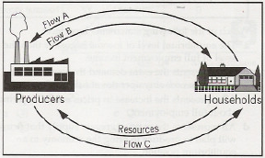

Which one of the following statements is correct?

- flow ‘A’ represents total expenditure in the economy.
- flow ‘C’ represents a real flow of factors of production.
- flow ‘B’ represents the dollar value of aggregate supply.
- flow ‘A’ represents the real flow of goods and services.

- Together, aggregate demand and aggregate supply determine the
Equilibrium of:

  - real domestic output but not prices
  - prices but not real domestic output
  - real domestic output and prices
  - neither real domestic output nor prices

- In the Keynesian model, inflation:

  - cannot be caused by government use of fiscal policy
  - is associated with high rates of unemployment
  - implies an equilibrium level of income in excess of the full employment level of income
  - is solely caused by excess growth of the money supply

- The diagram below shows an aggregate demand and aggregate supply curve for an economy.

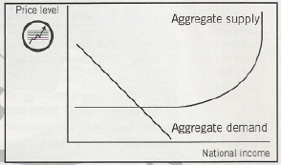

If there is an increase in aggregate demand there will be:

- a rise in prices immediately as firms take advantage of new profitable opportunities.
- a rise in prices if demand increases sufficiently to take up spare capacity.
- a rise in unemployment as workers begin to price themselves out of work.
- immediate inflation as the economy is working at full capacity.

- Which of the following is most likely to cause a downturn in economic
activity in a country that had experienced a long period of sustained economic growth?

  - a significant rise in the world oil price
  - a significant depreciation of the currency
  - a fall in the inflation rate
  - a fall in the unemployment rate

- If in a given economy, the marginal propensity to consume is 0.75, the
Top marginal rate of tax is 0.40 and the level of investment is $400m, then the size of the multiplier is:

  - 1.33
  - 4
  - 0.86
  - 1600

Question 11 to 13 refer to the following data. This data refers to an economy using the same definitions of employment and unemployment as those used by the ABS.

Total population | 18 million
Population of working age | 9 million
Not in the workforce | 3 million
Employed | 5 million
Unemployed | 1 million

11. The rate of unemployment in the economy to the nearest whole number is:

- 20%
- 17%
- 11%
- 6%

  - The participation rate in the economy, to the nearest whole number is:

- 14%
- 33%
- 50%
- 67%

  - The labour force in the economy is:

    - 18 million
    - 9 million
    - 6 million
    - 5 million

  - The basic cause of cyclic or demand deficient unemployment is:

      - people moving from one job to another but with a time gap between
      - insufficient mobility of the workforce to respond to changes in the pattern of the demand for labour
      - insufficient aggregate demand for domestically produced goods and services
      - embodied technological progress in manufacturing industries

15 Unemployment caused by insufficient aggregate demand for
domestically produced goods and services is called i) ______________
unemployment and short term unemployment caused as people move
from one job to another is called ii) ______________ unemployment.

- i) cyclical; ii) structural
- i) cyclical; ii) frictional
- i) structural; ii) frictional
- i) structural; ii) cyclical

16 The “Phillips Curve” relationship shows that, when the level of
aggregate demand falls:

- a rise in unemployment will cause a rise in inflation
- a fall in unemployment will cause a fall in inflation
- this rise in aggregate demand will cause a rise in employment and a fall in the rate of price increases
- a fall in expectations about future rate of inflation will cause a fall in actual inflation

17 According to the theory of comparative advantage, a good should be
produced in a nation where:

a) the production possibilities line lies further to the right than the
trading possibilities line.
    - its cost is least in terms of alternative goods which might otherwise
be produced.
    - its absolute cost in terms of real resources used is least.
d) its absolute money cost of production is least.

18. Which combination of policies would provide the greatest stimulus to
Domestic employment and output in the short run?

      - raising tariffs and providing subsidies for exports
      - lowering tariffs and providing subsidies for exports
      - lowering quotas on imports and placing taxes on exports.
      - Imposing quotas on imports and placing taxes on exports.

19. The diagram below shows the production possibility curves for computers and clothing in Japan and Malaysia.

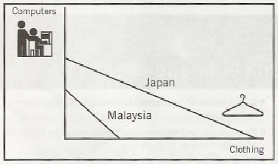

From the diagram it can be concluded that:

- Japan has absolute advantage in the production of both products
- The opportunity cost of producing clothing in Japan is less than in Malaysia.
- Malaysia has a comparative advantage in producing clothing.
- Malaysia cannot gain by trading with Japan.

20. 5% rise in the CPI means that:

- the prices of all goods brought in the economy have risen by 5%
- the purchasing power of the average metropolitan household income will have fallen by 5%
- the value of the $A will have fallen on average by 5% in terms of other currencies
- the prices of the goods and services that involve a large proportion of household expenditure all rose by 5%

21. Which of the following statements regarding Australia’s pattern of trade is
correct?

- Traditionally Australia has been a major importer of manufactured
products.
- Traditionally Australia has been a major importer of primary products.
- Traditionally Australia has been a major exporter of manufactured products.
- Traditionally Australia has been a major exporter of services.

22. The main change in Australia’s direction of trade has been from

- the Asian region to the American region
- the Indian Ocean region to the Pacific Ocean region
- Europe to the Asia-Pacific region
- The American region to the Asian region.

23. Which of the following would have least impact in limiting a country’s rate of economic growth?

- a shortage of skilled labour.
- the multiplier effect.
- a high marginal propensity to import.
- automatic fiscal stabilisation.

24. Allocative factors refer to:

- availability of resources
- domestic and overseas markets
- the efficiency of resource use
- the degree of government involvement in the economy.

25. Induced investment refers to spending which is

- unconnected with or unrelated to changes in income
- spent by firms to improve technology to keep up with competition
- related to an increase in income levels
- induced by a reduction in interest rates

END OF SECTION A

SECTION B

Data Interpretation (30 MARKS)

Suggested time: 60 minutes

Answer all THREE (3) questions. Each question is worth 10 marks

Write your answers in the spaces provided under each part question

26
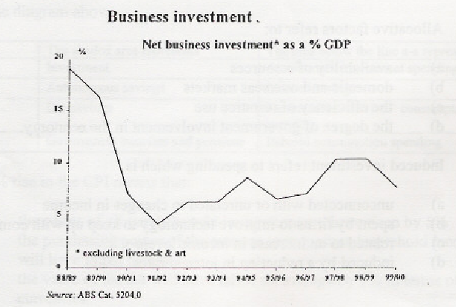

- In the period 1988/89 to 1999 / 2000, what has been

  - the highest level of net business investment? ________________
  - the lowest level of net business investment?________________
(2 marks)
b) Explain the dramatic fall in business investment after 1989 / 90. (3 marks)
________________________________________________________________________________________________________________________________________________________________________________________________________________________________________________________________________________________________________________________________________________________________________________________________________________________________________________________________________________________________________________________

c) Describe the relationship between the level of business investment spending and the trade or economic cycle. (5 marks)

________________________________________________________________________________________________________________________________________________________________________________________________________________________________________________________________________________________________________________________________________________________________________________________________________________________________________________________________________________________________________________________________________________________________________________________________________________________________________________________________________________________________________________________________________________________________________________________________________________________________________________________________________________________________
________________________________________________________________________________________________________________________________________________________________________________________________________________________________________________________________________________________________________________________________________________________________________________________________________________________________________________________________________________________________________________________________________________________________________________________________________________________________________________________________________________________________________________________________________________________________________________________________________________________________________________________________________________________________
________________________________________________________________________________________________________________________________________________________________________________________________________________________________________________________________________________________________________________________________________________________________________________________________________________________________________________________________________________________________________________________________________________________________________________________________________________________________________________________________________

27 Using the same amount of resources Country A and Country B have the
Production Possibility Frontier (PPF) for computers and meat as shown
below.

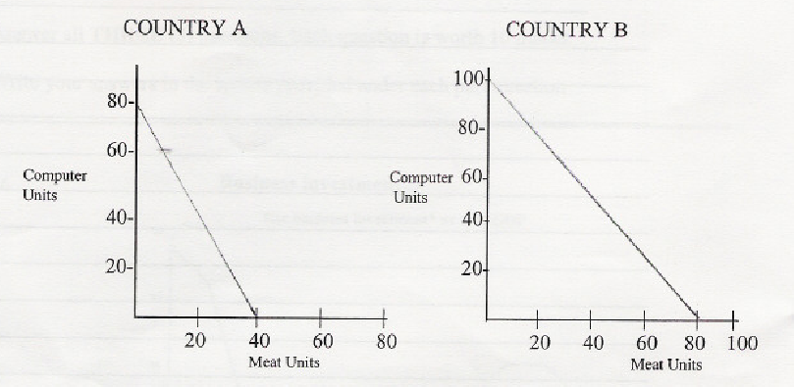

- Use the data from the production possibility curves to show where
each country has a comparative advantage.
____________________________________________________________________________________________________________________________________________________________________________________________________________________________________________________________________________________________________________
(2 marks)

- Define and explain the difference between Absolute and Comparative Advantage.
(3 marks)

____________________________________________________________________________________________________________________________________________________________________________________________________________________________________________________________________________________________________________________________________________________________________________________________________________________________________________________________________________________________________________________________________________________________________________________________________________________________________________________________________________________________________________________________________________________________________________________________________________________________________________________________________________________________________________________________________

- Use the theory of comparative advantage to demonstrate how both Country A and Country B could benefit through specialisation and trade. (NB graph paper provided if you wish to use it. (5 marks)
____________________________________________________________________________________________________________________________________________________________________________________________________________________________________________________________________________________________________________________________________________________________________________________________________________________________________________________________________________________________________________________________________________________________________________________________________________________________________________________________________________________________________________________________________________________________________________________________________________________________________________________________________________________________________________________________________
____________________________________________________________________________________________________________________________________________________________________________________________________________________________________________________________________________________________________________________________________________________________________________________________________________________________________________________________________________________________________________________________________________________________________________________________________________________________________________________________________________________________________________________________________________________________________________________________________________________________________________________________________________________________________________________________________
_________________________________________________________________________________________________________________________________________________________________________________________________________________________________________________________________________________________________________________________________________________________________________________________________________________________________________________________________________________________________________________________________________________________________________________________________________________________________________________________________________________________________________________________________________________________________________________________________________________________________________________________________________________________________________________________________________________________________________________________________________________________________________________________________________________________________________________________________________________________________________________________________________________________________________________________________________________________________________________________________________________________________________________________________________________________________________________________________________________

28.
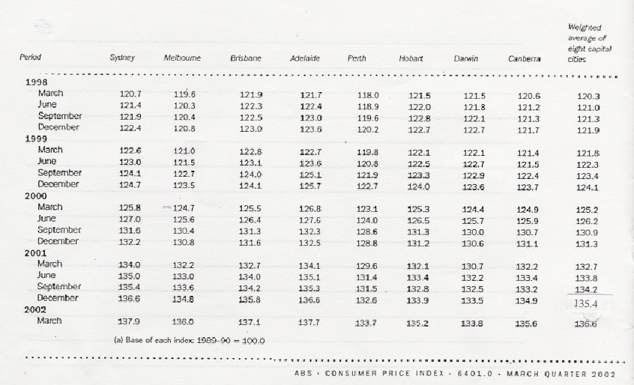

  - Calculate the percentage change in the inflation rate of:
  - the weighted average of all capital cities for 2001. (1 mark)
_________________________________________________________________________________________________________________________________________________________________________________________________________________________________

  - Perth for the year 2001. (1 mark)
______________________________________________________________________________________________________________________________________________________

  - Identify the year which showed the greatest increase in inflation (for all capital cities) and suggest the main causes of the increase in this particular year.

______________________________________________________________________________________________________________________________________________________________________________________________________________________________________________________________________________________________________________________________________________________________________________________________________________________________________________________________________________________________________________________________________________________________________________________________________________________________________________________________________________________________________________________________________________________________________________________________________________________________________________________________________________________________________________________________________________________________________________________________________________________________________________________________________________________________________________________________________________________________________________________________________________________________________________________________________________________________________________________________________________________________________________________________________
(3 marks)

  - What are the effects of higher inflation that make it undesirable for the Australian economy. (5 marks)

_________________________________________________________________________________________________________________________________________________________________________________________________________________________________________________________________________________________________________________________________________________________________________________________________________________________________________________________________________________________________________________________________________________________________________________________________________________________________________________________________________________________________________________________________________________________________________________________________________________________________________________________________________________________________________________________________________________________________________________________________________________________________________________________________________________________
_______________________________________________________________________________________________________________________________________________________________________________________________________________________________________________________________________________________________________________________________________________________________________________________________________________________________________________________________________________________________________________________________________________________________________________________________________________________________________________________________________________________________________________________________________________________________________________________________________________________________________________________________________________________________________________________________________________________________________________________________________________________________________________________________________________________________________________________________________________________________________________________________________________________________________________________________________________________________________________________________________________________________________________________________________________________________________________________________________________________________________________________________________________________________________________________________________________________________________________________________________________________________________________________________________________________________________________________________________________________________________________________________________________________________________________________________________________________________________________________________________________________________________________________________________________________________________________________________________________________________________________________________________________________________________________________________

SECTION C

Essays and extended answers (45 marks)

Suggested time: 60 minutes

Answer any THREE (3) QUESTIONS. Each question is worth 15 marks

29 a) Describe the components of aggregate expenditure in the Australian
economy. (6 marks)

- Discuss the factors which might cause aggregate expenditure to
change. (Illustrate your answer by reference to recent Australian
experience where possible). (9 marks)

30 a) Use a diagram to illustrate how a tariff raises revenue for the
government and protects domestic producers. (7 marks)

b) Describe the impact of the reduction of trade barriers, both domestic
and overseas, on the Australian economy. (8 marks)

31 a) Briefly explain the concept of ‘economic growth. (3 marks)

b) Outline the main causes of economic growth in an advanced economy such as Australia. (6 marks)

c) Discuss the possible effects of economic growth on unemployment. (6 marks)

32 a) Define the term foreign debt and explain the link between Australia’s foreign debt and the balance of payments. (7 marks)

b) Discuss the economic costs and benefits of an increase in the level of foreign debt. (8 marks)

Begin answers to Section C below.

